Job Description

Job Holder: Head of Learning & Development

Reports to: Human Resources Director

Grade: PM3

Safety Status: Non-safety critical

Date version agreed: 16 February 2018

1. Job Purpose
- The Head of Learning and Development will develop and implement the Organisational Development strategy for WMT joining together all elements of learning and organisational development such that the business understands the interdependencies of an integrated approach.
- Ultimately responsible for the development and implementation of WMT’s Learning, Development and Operations Training strategy in line with the HR strategy, budget and franchise commitments as well as annual business plans, KPIs, standards of excellence and annual activity plans.
- Determines and implements appropriate solutions for leadership capability frameworks, talent and succession plans, training opportunity for all employees, performance management processes, high potential programmes and ensures we remain accredited with Investors in People and seeks accreditation also with Investors in Diversity.
- Develops and delivers an accredited Leadership Development approach which supports organisational development and maximises the contribution of leaders and colleagues at all levels to the overall success of the business.
- Responsible for developing, leading and embedding a culture of change across WMT in line with the Culture and Values programme and reporting annually on progress to the Secretary of State.
- Assuring that WMT has the training capacity to deliver the training requirements of the train crew and stations resource plan in line with the requirements to introduce new and additional services and improve fleet capacity.

3. Dimensions

A. Financial:
Payroll and Activity Budget of £1.2m in 17/18 rising to £1.6m in 18/19 before normalising at around £1m from 21/22.

B. Staff:
Directly Responsible for 12 staff including two direct reports – Training Academy Manager and a Learning and Development Manager

C: Others:
Fully responsible for leadership, development and resourcing of department and assurance of operational standards within operational training team

4. Principal Accountabilities
- Leads a current team of 12 including 9 operational training specialists and 3 learning and development practitioners to develop and implement a Learning, Development and Operations Training strategy, to provide a training and development service to the business including a portfolio of solutions and interventions.
- Deliver strategy, policy and frameworks for the accredited development of management and leadership in the business, including a framework for talent management and succession planning.
- Develops best practice people activities and training events to support technical (vocational and non-vocational) and behavioural competency for all employees, ensuring selected groups have realistic, stretching and active career and development plans.
- Ensures that training records for all staff accurately reflect the training and development activities undertaken by the individual, thus supporting the competency management system for safety critical employees.
- Embeds a robust performance management framework aligning individual objectives to business plan, core values and behaviours, to ensure performance management is embedded into the organization.
- Acts as WMT’s representative for external training bodies and forums, continually benchmarking WMT’s training policies with others in and outside the Rail Industry, identifying best practice, partnering and funding opportunities. WMT representative for the Abellio People Potential work stream
- Responsible for early career development initiatives and the management of high potentials, young people and ensures WMT gets best leverage from the apprenticeship levy.
- Leads an innovative range of blended learning and development interventions for all groups of employees that are aligned with achievement of the WMT business plans and objectives.
- Leads on ROI, utilising results measured through business KPIs demonstrating the impact of training, learning and development on performance
- Leads on the talent strategy for WMT and supports progression of the associated tools and action plans to positively influence engagement and succession.
- Builds stakeholder relationships to secure key development accreditations and promotes development tools. Ensure practises are communicated, embraced and implemented by the WMT colleague population.
- Delivers the annual training needs analysis and training plan.

5. Context

A: Operating Environment:
- Ensuring learning, training and development has visibility across the business, ensuring it delivers in line with business plan and the organisation development strategy
- Ensuring best leverage of cash available through robust plans and business cases
- Measures such that confidence, capability and standards can be satisfied after the intervention of development

B: Framework and Boundaries:
- Operational training must be aligned to operational standards
- Leadership development must be aligned to the Abellio Leadership framework
- Where possible, all leadership training should be accredited to ILM standards
- A basic awareness of the WMT safety management system, environmental management system and the risk assessment process, Railway Standards as well as the Health and Safety at Work Act 1974

C: Organisation:
Please see organisation chart

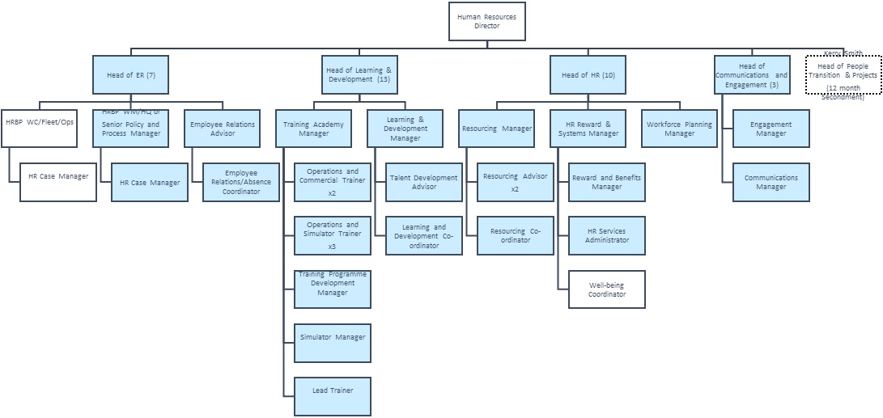

6. Relationships

A: Reporting lines
The role reports to the Human Resources Director

B: Other Contacts:
The role interfaces with the Executive and the top 40 as well as other key internal stakeholders

Outside the Company:
External stakeholders comprise mainly of Abellio Group and Abellio Operating Company contacts as well as industry bodies and key suppliers of learning and development solutions.

7. Knowledge and Experience
- Degree level or equivalent in HR/Organisational Development or relevant discipline
- Strong leadership skills and be able to demonstrate how they were successfully deployed across a range of strategic and challenging scenarios
- Strategic leadership in the development and successful implementation of HR and Organisational Change strategies aligned to strategic business imperatives
- Experience of leading change through a planned organisational design approach incorporating best practice systems and tools
- Evidence successful delivery against challenging change and cost reduction plans within a unionised environment
- Experience of dealing first hand with Trade Unions internally and at FTO level – developing and leading the approach to consult and negotiate change to established training regimes where agreed
- Successfully operating within complex working environments and delivering through a matrix of diverse relationships
- Ability to operate within a changing and challenging work environment – building strong and effective relationships across the business to source information and garner support for organisational development initiatives

8. Job Challenge(s):
- An attitude that is geared towards finding solutions to complex problems through working positively with staff and in strong collaboration with your customer base and wider stakeholders
- Skills in leading, coaching and managing a large staff will be required
- Exceptional interpersonal, negotiating and presentation skills
- Excellent communication, internally and externally with the ability to communicate complex information clearly and concisely
- A strong working knowledge of the latest developments in HR and Organisational Development
- A commitment to your own and others personal development
- You will need to demonstrate personal resilience

9. Additional Information
- Quick and agile compilation of plans and approaches will be required when there is little to go on
- The post holder will be required to deliver a number of committed obligations to the DfT
- An ability to work without detailed direction and with a degree of ambiguity will be required
- Leading the relocation of the training academy and simulators may be a feature of the role within the first 24 months

10. Sign off

Job Holder:……………………………………………….. Date:………………..

Manager:………………………………………………….. Date:………………..

Nominated Deputies

If this is a KEY SAFETY POST (2D is “checked”) a Nominated Deputy must be identified. The job holder must ensure that the Nominated Deputy receives a copy of, and is briefed on, this Job Description.

Job title of Nominated Deputy: …………………………………………………..………..…….

Name of Nominated Deputy: ……………………………………………….………..………..….

Signature of Nominated Deputy: …………………………………………….………..…………

Date: ………………………………………………………………………………….………..………..

As the Nominated Deputy for this post, I confirm that I have been briefed on the requirements of this job. If there are more Nominated Deputies they should sign further copies of this Job Description.

